ECA0302 – SIGNALS AND SYSTEMS
NAME: RAGAVARSHINI R
REG.NO: 192512027
CO4 - EXP –(17,18)
Generate a continuous-time sinusoidal signal and sample it at sub-Nyquist, Nyquist and super-Nyquist rates.
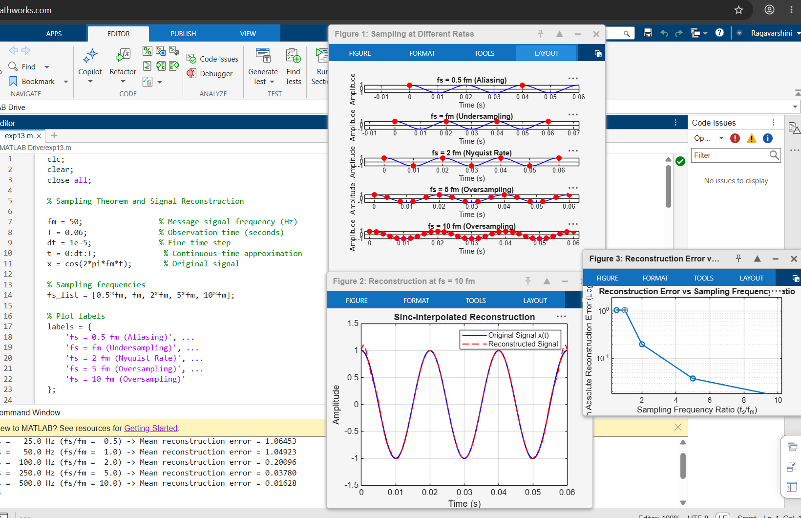
Compute the DTFT of finite-length discrete-time sequences.

